CAIT Guidelines for Refined Analysis

Of Steel Multi-Girder Bridges

# Preamble

Finite Element (FE) analysis of multi-girder bridges provides an effective way of predicting the response of a structure to a wide variety of loading conditions. Often the predicted responses are used to compute a conservative measure of the structure’s reserve capacity in the form of rating factors. This document is meant to serve as a set of guidelines for performing the tasks necessary for this process.

# Modeling

This section provides information about gathering of structural dimensions and details, finite element (FE) model construction, and FE model error screening.

## Structure Dimensions & Material Properties

Structure dimensions/details, material properties, and any other pertinent information is provided by the bridge owner in the form of construction documents or inspection reports. If no plans are available, or if there is missing information, dimensions and material properties may be measured in the field or assumed based on engineering judgement. The following list provides the typical global dimensions and component details that are required before modeling is initiated:

* Number of spans/continuity
* Span Length(s)
* Bridge Width (Roadway Width, Out-to-out Width)
* Number of Lanes & Lane Widths
* Skew
* Girder Spacing & Number of Girders
* Overhang Width
* Deck Thickness
* Barrier Section (Height, Width, or other dimensions describing the cross-section)
* Sidewalk Dimensions
* Girder Section (Flange Width/Thickness, Web Thickness, or other dimensions describing the cross-section)
* Number of Diaphragms and Diaphragm Spacing
* Diaphragm Section
* Material Properties (Concrete Strengths, Steel Yield Strength)

## Model Form

There exists a wide range of modeling techniques that may be used to simulate the behavior of common multi-girder bridges. The two modeling techniques employed in these guidelines are the element-level and shell element methods of modeling. Both methods can reasonably simulate most bridge responses but each has its own limitations.

The element-level model is the most common class of 3D finite element models employed for constructed systems (ASCE, 2013). This model employs one-dimensional elements (beam elements) to model girders, diaphragms, and barriers, and two-dimensional (plates/shell elements) to model the deck and sidewalks. In an element-level model, a girder is discretized into 1D beam elements with the cross-section applied through the definition of geometric properties (e.g. area, moment of inertia, etc.). Link elements are used to connect components (i.e. girders to the deck, diaphragms to the girders, etc.) to remain consistent with the 3D geometry of the structure. Figure X below is a schematic that shows how the 3D geometry of the bridge is simulated using the beam, shell, and link elements described. An element-level model can reasonably simulate most bridge responses; however, the shortcomings of this method include: (1) an inability to effectively simulate warping deformation of girders (associated with torsion), and (2) an inability to simulate localized stresses (i.e. stress concentrations) associated with geometric discontinuities. These shortcomings may be critical when modeling construction sequences for complex bridges (White et al. 2012), or for advanced fatigue/fracture assessment, however they are not relevant for the global limit states that are evaluated in load rating.

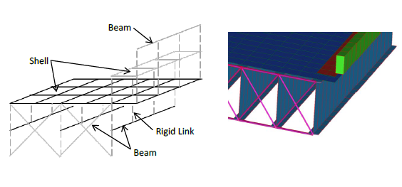

The most significant distinction between element-level and shell element models of multi-girder bridges is that the girder in shell element models are discretized vertically, laterally, and longitudinally using shell elements. Additionally, link elements are used along the cross-section of the girder to enforce compatibility. Unlike the element-level model, the shell element model allows for accurate simulation of the warping of girders due to torsion, and the simulation of localized stresses (i.e. stress concentrations). Some caution is advised when using shell element models as erroneous localized stress concentrations may become apparent. Moreover, shell element models may be undesirable for common use as model construction, computation, and result extraction activities are more time consuming and more difficult than with element-level models. Figure X below shows how the 3D geometry of the bridge is represented using a shell element model.

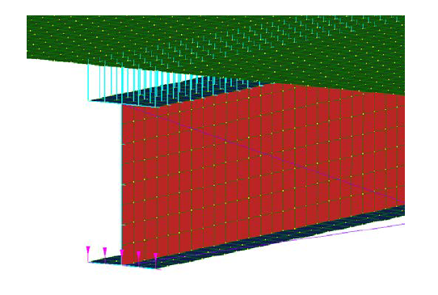

Unless otherwise noted, all steel multi-girder bridges are modeled using the element-level modeling method. The following sections provide a more detailed description of the modeling of each component of the bridge superstructure.

### Girders & Diaphragms

Girders and diaphragms are modeled using 2D beam elements. The section geometry and material properties of the girders and diaphragms are assigned to the beam element property in the finite element software. The beam elements are placed at the centroid of the section. Nodes are placed at the top and bottom surfaces of the girder flanges. Rigid links are used to enforce compatibility between the top and bottom surfaces of the girder flanges by connecting the girder centroid to the top and bottom flange nodes. These nodes may be used to connect diaphragms, enforce composite action by linking to the deck, or as boundary nodes. Depending on the type and configuration of the diaphragm, the diaphragm beam elements can connect to the top or bottom flange nodes or to the girder centroid node. If connections exist in other locations on the girder, nodes may be placed at the connection location on the girder and linked to the top/bottom flange nodes or girder centroid node. Figure X shows a schematic of a typical girder-diaphragm connection.

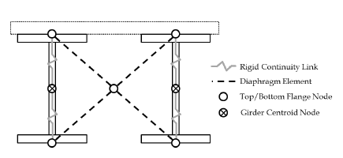

### Deck

The concrete deck is modeled using three- and four-node shell elements depending on the configuration needed. These shell elements are assigned a bending and membrane thickness equivalent to the thickness of the concrete deck. Deck nodes are located at the center of the shell element thickness. Composite action of the deck may be enforced by connecting the girder nodes and the deck nodes with rigid link elements.

### Sidewalk & Barriers

Sidewalks are modeled using three- and four-node shell elements similar to the deck. Barriers are modeled using 2D beam elements with the actual cross-section or as a rectangular cross-section as desired (see Section 3 on modeling decisions and assumptions). Barriers and sidewalks are connected to the deck nodes with rigid link elements to enforce continuity.

### Boundary Conditions

Boundary conditions may be enforced as described in Section 2.3. Boundary conditions may be modeled and/or updated to reflect field observations or findings from experimental data.

### Composite Action

Composite action is typically enforced by using a rigid link to connect the girder nodes to the deck nodes. As an alternative to rigid links, beam elements may be used to connect the girder nodes to the deck nodes. This method allows for the magnitude and spatial degree of composite action to be modified by manipulating the stiffness of the beam element.

### Element Discretization

Element discretization is relative to the size of the structure. It is important to coordinate the mesh sizing between the girder and deck elements so that adjacent nodes line up in parallel or perpendicular global grid coordinates. A few rules of thumb are as follows: (1) limit the aspect ratio of most shell element dimensions to 2:1, with none having an aspect ratio greater than 5:1, (2) elements should be discretized at approximately 1/6 to 1/8 of the girder spacing. For typical multi-girder bridges it is recommended that models should have an average element size of 12-24 inches.

## Modeling Decisions & Assumptions

The following guidelines detail optional modeling decisions or assumptions.

### Modeling of Haunches

For structures with a concrete haunch, explicit modeling of the haunches using beam or shell elements is not required. Instead, the girder beam elements may be offset an additional distance equivalent to the depth of the concrete haunch. The offset serves to effectively increase the moment arm between the centroid of the deck and the centroid of the steel beam to match the geometry of the actual structure. This method ignores the mass of the haunches so it is important to note that, when using this method, the dead load due to the concrete haunches must be added to the model. This may be accomplished in several ways, the simplest of which is to include distributed loads in the model corresponding to the weight of the haunch.

This decision was made after comparing the responses of a sample structure under its own weight for three methods of modeling the haunch (offsetting the girder beam elements and adding a distributed load, or explicitly modeling the haunches with beam and shell elements). The responses compared were those used for load rating: bending and axial. A negligible difference in response was observed between the three methods. In fact, using the offset method proved to decrease the time needed for modeling and results extraction. As such, haunches may be considered by using the offset method described.

### Modeling of Barriers

The stiffness contribution of steel or concrete barriers may be ignored in analysis. Masceri (2015) found that when barrier stiffness was included (assuming continuity along the entire length of the barrier as well as full continuity with the deck) rating factors for interior and exterior girders increased compared to when barrier stiffness was ignored. This optimal level of continuity is unrealistic and the actual stiffness of the barriers is uncertain due to construction details (saw cuts, rebar continuity, etc.). Given these findings, it is conservative to ignore the stiffness of the barriers. This is accomplished by assigning the barrier beam elements with an arbitrarily small modulus of elasticity.

Additionally, the barrier element may be assigned a rectangular cross-section using the largest height and width dimensions of the barrier. Assuming a rectangular cross-section with the largest dimensions can save modeling time for barriers with complex shapes and is conservative as it increases the dead load.

### Boundary Conditions

Boundary conditions may be defined based on construction drawings, inspection reports or field observations. In the absence of such information, the boundary conditions should be defined to provide the least amount of restraint while keeping the model stable. Assigning the least restraint avoids problems that may result from over-constraining the model. This is achieved by restraining all supports in the vertical direction, restraining the exterior girders in the longitudinal direction at one abutment, and restraining the central girder in the transverse direction at that same abutment. In this manner local self-equilibrating forces are avoided. Unless there is evidence opposing this modeling decision (i.e. inspection report, plans, etc.) all models should be restrained in this fashion. Figure XX below shows a 2-Span continuous structure as an example of boundary conditions imposed in this manner.

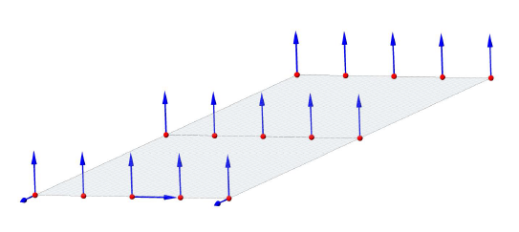

### Composite vs. Non-Composite

Depending on the location and response, the cross-section may be considered composite or non-composite. Unless noted otherwise, cross-sections in regions of positive flexure are considered composite. Responses in this region are evaluated against the resistance of the fully composite section. For multiple-span continuous bridges, cross-sections in regions of negative flexure are considered non-composite. That is, the deck is assumed to provide no resistance to tensile forces. Responses in this region are evaluated against the resistance of the non-composite (beam only) section.

## Error Screening

After a model is built and before analysis is conducted, the model is error screened for proper geometric and material properties as well as modeling decisions by someone other than the original modeler. If an error is found, it is noted for the original modeler to make the proper corrections. Table XX below provides a list of all aspects of the model that are checked during errors screening.

|  |  |
| --- | --- |
| GEOMETRY & MODELING ASPECTS | DESCRIPTION |
| Clean Mesh | Verify there are no duplicated node, beam or shell elements |
| Dead Load | Verify that the total dead load of the model approximates that of the actual structure |
| Wearing Surface | Verify correct assignment and specifications of the wearing surface in the model |
| Beam Cross Sections | Check that the correct beam cross sections are assigned |
| Beam Material | Check that the correct beam material properties are assigned |
| Beams Location/Offset | Check the correct beam dimensions/location and offset is assigned. (If offset tool is used) |
| Beams Spacing | Verify that the beam spacing corresponds to the drawings or actual measurements. |
| Haunch Cross Section | Check that the girders are located correctly to account for the haunch. |
|  |  |
|  |  |
| Plate Cross Section | Check that the correct plate thickness was assigned. |
| Plate Material | Check that the correct material properties are assigned. |
| Plate Location/Offset | Check the correct dimensions/location and offset is assigned. (If offset tool is used) |
| Plate Overhang | Verify the measurements of the deck overhang. |
|  |  |
|  |  |
|  |  |
| Supports Location | Verify the correct location of all bridge supports. |
| Supports Definition | Check for proper support conditions at each support (DX, DY, DZ, RX, RY, RZ) |
| Span Length | Verify that the measurement of the span length corresponds to the drawings or measurements |
| Connectivity | Check that all elements in the model have the proper connectivity (through rigid links or sharing of nodes) |
| Load Cases | Check that all load cases are properly defined |
| Load Path Properties | Check that all load paths are properly defined |
| Load Path Location | Verify that all load paths are properly located |
| Parapet Cross Section | Check that the correct parapet cross section is assigned |
| Parapet Material | Check that the correct parapet material properties are assigned. |
| Railing Cross Section | Check that the correct railing cross section is assigned. |
| Railing Material | Check that the correct railing material properties are assigned. |
| Diaphragm Cross Section | Check that the correct diaphragm cross sections are assigned. |
| Diaphragm Spacing | Verify that the diaphragm spacing corresponds to the drawings or measurements. |
| Diaphragm Geometry | Verify the proper configuration of diaphragm beam elements |

# Dead Load & Live Load Analysis

## Dead Load

Three dead load cases are considered separately, initial dead load, superimposed dead load, and dead load from the wearing surface. Each load case is defined by manipulating the mass and stiffness through material properties (density and modulus of elasticity) of specific components of the structure. This section provides a description of each dead load case as well as the application of each case.

### Initial Dead Load (DC1)

Included in the initial dead load case is the self-weight of the steel components (girders, diaphragms, and connections) as well as the self-weight of the deck. For analysis of this load case, the stiffness of the steel component is included but the stiffness of the deck is not. This is achieved by setting the modulus of elasticity for the deck to an arbitrarily small value before running the linear static solver in Strand7, ensuring that the dead load of the un-cured concrete is accounted for while providing no stiffness. Table X below summarizes the state of each component for this load case.

|  |  |  |  |  |
| --- | --- | --- | --- | --- |
| **Component(s)** | **Mass** | **Stiffness** | **Density** | **Modulus** |
| Girders, Diaphragms, Connections | Yes | Yes | Specified density of component(s) | Specified modulus of component(s) |
| Deck | Yes | No | Specified density of component(s) | 1.0 lb/in2 |

### Superimposed Dead Load (DC2)

Superimposed dead load considers only the self-weight of the components that were built after the deck has cured (e.g. sidewalks and barriers). The stiffness of these components is ignored by setting their modulus of elasticity to an arbitrarily small value. The stiffness of the cured concrete deck is included but the mass of the deck and all steel components (girders, diaphragms, and connections) is ignored for this load case by setting the density of each component to 0. This ensures that the dead load for each component is only accounted for once.

|  |  |  |  |  |
| --- | --- | --- | --- | --- |
| **Component(s)** | **Mass** | **Stiffness** | **Density** | **Modulus** |
| Girders, Diaphragms, Connections | No | Yes | 0 lb/in3 | Specified modulus of component(s) |
| Deck | No | Yes | 0 lb/in3 | Specified modulus of component(s) |
| Sidewalks, Barriers | Yes | No | Specified density of component(s) | 1.0 lb/in2 |

### Wearing Surface (DW)

The wearing surface may be applied to the structure in one of two ways. The first is to use non-structural lumped mass on the deck nodes with a mass equivalent to that of the wearing surface over the tributary area of each node. The second is to model the wearing surface as a second layer of shell elements with the proper material properties, thickness, and geometric offset. The stiffness of the wearing surface is not considered and therefore only contributes to the overall dead load. Stiffness of the barriers and sidewalks is also ignored. Table X below summarizes the state of each component for this load case.

|  |  |  |  |  |
| --- | --- | --- | --- | --- |
| **Component(s)** | **Mass** | **Stiffness** | **Density** | **Modulus** |
| Girders, Diaphragms, Connections | No | Yes | 0 lb/in3 | Specified modulus of component(s) |
| Deck | No | Yes | 0 lb/in3 | Specified modulus of component(s) |
| Sidewalks, Barriers | No | No | 0 lb/in3 | 1.0 lb/in2 |
| Wearing Surface | Yes | No | Specified density of component(s) | 1.0 lb/in2 |

## Live Load

Live load is analyzed using Strand7’s load path feature and the built-in Load Influence Solver. This section defines the load cases considered (for LRFR HL-93, LFR HS20, and respective legal loading) and provides detailed documentation for the analysis of live loads conducted with Strand7.

### Strand7 Load Influence Solver

Strand7’s Load Influence Solver is used to determine the influence that a point load or series of point loads has on a response at a specified location. In Strand7, Response Variables (RVs) are assigned to beam elements at locations where a maximum response (shear force, bending moment, etc.) is anticipated. Load paths are defined for each loading scenario and the Load Influence Solver is used to determine the loading configuration that gives the maximum response at the location of each RV. Final analysis is conducted using the static loading conditions developed through the load influence solver.

#### Response Variables for Flexure

RVs for flexure are assigned to beam elements at locations where it is assumed the maximum flexural response (positive or negative) will occur. This location depends on the structure type and/or continuity of the bridge as well as the support conditions. Under typical loading conditions, simple span bridges experience maximum positive flexure at mid span, therefore flexure RVs are assigned to each member at 0.5L. Multiple span continuous bridges experience maximum positive flexure between supports at a location within 0.4L and 0.45L. For continuous bridges with different span lengths or nonsymmetrical plan arrangements the positive flexure RVs should be assign to each member where the maximum positive dead load moment occurs. Negative flexure occurs over interior supports of multiple-span continuous bridges; therefore, flexure RVs should be assigned to each member over each interior support.

Positive Flexure

Positive Flexure

Negative Flexure

Positive Flexure

#### Response Variables for Shear

For most typical bridges (symmetric, multi-girder bridges) maximum shear will occur in members directly over the supports. RVs for shear are placed in these locations. For non-typical bridges, a controlling shear response may also occur at connection locations. For these special cases, the locations of the RVs are left to the discretion of the engineer.

Shear Response

Shear Response

Shear Response

Shear Response

Shear Response

### Definition of Live Load Cases

Load path templates are created for all design and legal load trucks for both LRFR and LFR. Each template contains the properties for each load case, including the truck axle spacing and loading configuration as well as lane loading. Several aspects are considered when assigning Live Load (LL) properties and configurations to the bridge models using the load path feature in Strand7. The number of lanes is defined in the load path template and is determined as the integer part of the road width (clear distance from curb to curb) divided by 12ft. Multiple Presence Factors (*m*) taken from AASHTO Specifications are assigned in the load path template to account for the probability of simultaneous lane occupation. Table XX below contains the multiple presence factors used for LRFR and LFR analysis. Additionally, an impact factor is applied to each load. FIGURE XX is a screen shot of the load path template for LRFR HL-93 loading, presented as an example.

|  |  |  |
| --- | --- | --- |
|  | Multiple Presence Factors, m | |
| Number of Lanes | LRFR | LFR |
| 1 | 1.20 | 1.00 |
| 2 | 1.00 | 1.00 |
| 3 | 0.85 | 0.90 |
| > 3 | 0.65 | 0.75 |

Table 3.6.1.1.2-1. Multiple Presence Factors, *m*. AASHTO LRFD Bridge Design Specifications, 2012.

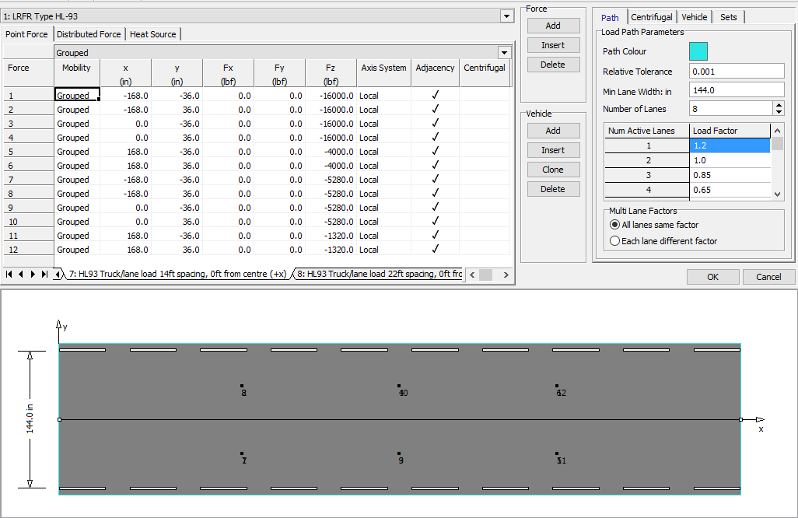

Image xx. Type HL-93 Truck. Strand7 Load Path Configuration.

The specifications for each truck type are provided herein.

#### HL-93

The configuration of the HL-93 loading is shown in Figure XX below. The loading configurations created in the load path template represent the different truck arrangements for the HL-93 truck and lane loading defined in the AASHTO Manual for Bridge Evaluation. Lane crowding is accounted for in the load path by allowing the trucks to shift one foot from the center of the lane in either direction. The loading scenarios for HL-93 are listed below.

* HL-93 Design truck (Spacing 14’-14’)
* HL-93 Design truck (Spacing 14’-22’)
* HL-93 Design truck (Spacing 14’-30’)
* 90% of dual HL-93 design truck (Spacing 14’-14’), internal spacing of 50’ (for continuous only)
* 90% of dual HL-93 design truck (Spacing 14’-14’), internal spacing of 100’ (for continuous only)



* Design Lane load (640 lb/ft)
* Tandem truck type

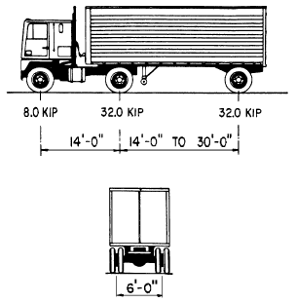

Image xx. Standard HL-93 Truck. AASHTO 3.6.1.1.2.2-1 Characteristics of Design Truck.

Weight = 72K (36T)

#### HS20, HS20-M, HS20-S

The 72 kip truck load for LFR HS20 is distributed over three axles as shown in Figure XX below. The distances between the first and second axel is fixed on 14 feet and the distance between the second and third axel varies from 14 feet to 30 feet. Lane crowding is accounted for in the load path by allowing the trucks to shift one foot from center of lane in either direction of the lane. Additionally, special cases for moment and shear evaluation are considered (HS20-M and HS20-S). The loading cases for HS20, HS20-M, and HS20-S are shown in the figures below.

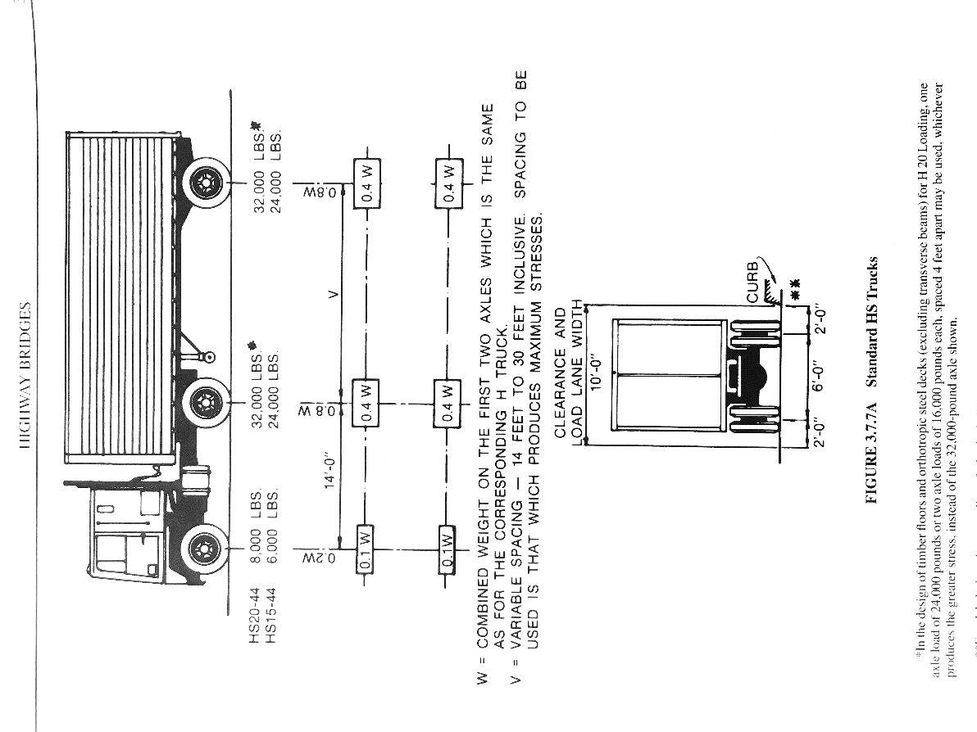

Image xx. Standard HL20Truck. AASHTO Standard Specifications for Highway Bridges 3.7 Highway Loads. Weight = 72K (36T)

#### Type 3

The load configuration defined in Strand7 for Type 3 Legal Load is shown in Figure XX below, with loads shown for LFR. The loads for LRFR include the impact factor. The axle loads for LRFR Type 3 with applied impact factor are 21.28K, 22.61K and 22.61K . Lane crowding is accounted for in the load path by allowing the trucks to shift one foot from center of lane in either direction of the lane.

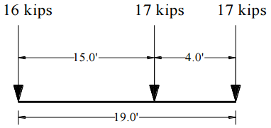

Image xx. Type 3 Truck. AASHTO Legal Truck. Weight = 50K (25T)

#### Type 3S2

The load configuration defined in Strand7 for Type 3S2 Legal Load is shown in Figure XX below, with loads shown for LFR. The loads for LRFR include the impact factor. The axle loads for LRFR Type 3S2 with applied impact factor are 15.96K, 22.61K, 22.61K, 22.61K and 22.61K. Lane crowding is accounted for in the load path by allowing the trucks to shift one foot from center of lane in either direction of the lane.

12 kips

17 kips

17 kips

17 kips

17 kips

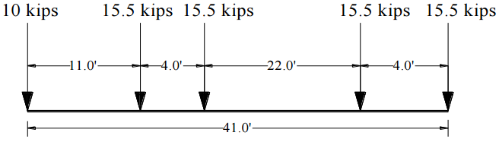

Image xx. Type 3S2Truck. NJDOT Legal Truck. Weight = 72K (36T)

#### Type 3-3

The load configuration defined in Strand7 for Type 3-3 Legal Load is shown in Figure XX below, with loads shown for LFR. The loads for LRFR include the impact factor. The axle loads for LRFR Type 3-3 with applied impact factor are 15.96K, 15.96K, 15.96K, 21.28K, 18.62K and 18.62K. Lane crowding is accounted for in the load path by allowing the trucks to shift one foot from center of lane in either direction of the lane.

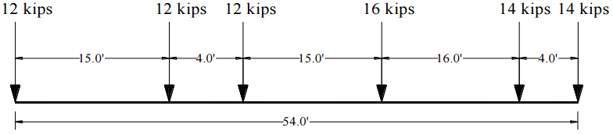

Image xx. Type 3-3 Truck. AASHTO Legal Truck. Weight = 80K (40T)

#### Type 3-3 75% (For multiple-span continuous only)

The load configuration defined in Strand7 for Type 3-3 75% Legal Load is shown in Figure XX below, with loads shown for LFR. The loads for LRFR include the impact factor. The axle loads for LRFR Type 3-3 75% with applied impact factor are 11.97K, 11.97K, 11.97K, 15.96K, 13.96K and 13.96K. Lane crowding is accounted for in the load path by allowing the trucks to shift one foot from center of lane in either direction of the lane.

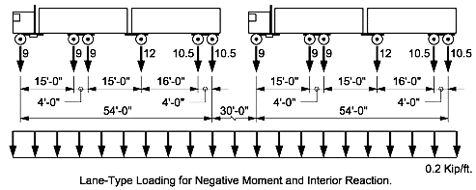

Image xx. Type 3-3 75% Truck. AASHTO Manual for Bridge Evaluation. Weight = 60K (30T) each.

#### SU4

The load configuration defined in Strand7 for SU4 Legal Load is shown in Figure XX below, with loads shown for LFR. The loads for LRFR include the impact factor. The axle loads for LRFR SU4 with applied impact factor are 15.96K, 10.64K, 21.61K and 21.61K. Lane crowding is accounted for in the load path by allowing the trucks to shift one foot from center of lane in either direction of the lane.

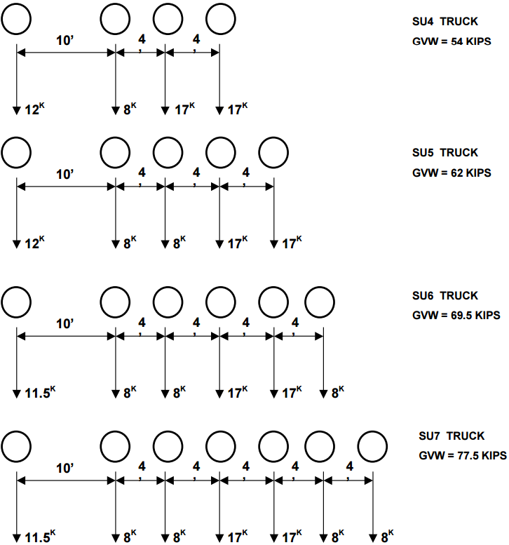

Image xx. SU4 Truck. AASHTO Manual for Bridge Evaluation. Weight = 54K (27T) each.

#### SU5

The load configuration defined in Strand7 for SU5 Legal Load is shown in Figure XX below, with loads shown for LFR. The loads for LRFR include the impact factor. The axle loads for LRFR SU5 with applied impact factor are 15.96K, 10.64K, 10.64K, 21.61K and 21.61K. Lane crowding is accounted for in the load path by allowing the trucks to shift one foot from center of lane in either direction of the lane.



Image xx. SU5 Truck. AASHTO Manual for Bridge Evaluation. Weight = 62K (31T) each.

#### SU6

The load configuration defined in Strand7 for SU6 Legal Load is shown in Figure XX below, with loads shown for LFR. The loads for LRFR include the impact factor. The axle loads for LRFR SU6 with applied impact factor are 15.29K, 10.64K, 10.64K, 21.61K, 21.61K and 10.64K. Lane crowding is accounted for in the load path by allowing the trucks to shift one foot from center of lane in either direction of the lane.



Image xx. SU6 Truck. AASHTO Manual for Bridge Evaluation. Weight = 69.5K (34.75T) each.

#### SU7

The load configuration defined in Strand7 for SU7 Legal Load is shown in Figure XX below, with loads shown for LFR. The loads for LRFR include the impact factor. The axle loads for LRFR SU7 with applied impact factor are 15.29K, 10.64K, 10.64K, 21.61K, 21.61K, 10.64K and 10.64K. Lane crowding is accounted for in the load path by allowing the trucks to shift one foot from center of lane in either direction of the lane.



Image xx. SU7 Truck. AASHTO Manual for Bridge Evaluation. Weight = 77.5K (38.75T) each.

# Results Extraction & Filtering

## Locations for Results Extraction

The response locations of interest – from which results are extracted – are described in this section for typical and non-typical bridges. Typical bridges represent the population bridges sharing similar geometric properties (i.e. symmetrical, multi-girder, etc.) such as common highway overpass bridges. Non-typical describe bridges with a rather complex design (i.e. thru-girder/floor beam systems, masonry arches, and other more signature bridges).

### Typical Simply Supported Multi-Girder Bridges

For flexure, results are extracted from the locations where the flexure RVs were placed. This is where positive flexure responses are maximum. For shear, results are extracted from the location where the shear RVs were placed. This is where shear responses are maximum.

### Typical Multiple-Span Continuous Multi-Girder Bridges

For multiple-span continuous structures, flexure results are extracted from the locations where the flexure RVs were placed. Shear results are extracted from the location where the shear RVs were placed.

### Non-Typical Bridges

The locations of interest for non-typical bridges are left to the discretion of the person conducting the refined evaluation of the structure. These will typically exist were the maximum positive and/or negative flexure and shear responses occur.

## Flexure

For flexure responses, components of total moment are extracted from the beam and adjacent shell elements. In order to compute the full composite moment at the particular cross-section of interest, three response components were extracted from each location. These components are major axis bending moment in the beam element (M1), axial force in the beam element (P), and bending moment in the adjacent shell elements (M22). The adjacent shell elements are those in a transverse row within the effective width of each longitudinal member. The bending moment in the adjacent shell elements is only considered for load cases where the stiffness of the deck is considered (i.e. all except initial dead load). Equation X below gives the calculation used to determine the total moment that acts on the cross-section, in which “y” equals the distance between the deck centroid and beam element centroid.

|  |  |
| --- | --- |
| $$Total Moment, M_{Total}=M_{1}+Py+\sum{M_{22}}$$ | (1) |

Flexural responses are evaluated for both composite and non-composite sections depending on the response type and location.

## Shear

The method of extracting shear responses depends on the location of where the response is being extracted. Shear responses over exterior supports are taken as the reaction at the support. This conservatively assumes that the value of the reaction is the absolute maximum shear in the girder. Shear responses over interior supports or at element connection locations are taken as the absolute maximum shear response in the beam element assuming there is no contribution from the concrete deck. The decision to extract shear responses using these two methods was a result of findings from a parametric study conducted by CAIT research personnel. It was found that shear responses over exterior supports differed from what was expected depending on the model type an element discretization. This was not the case, however, for responses over interior supports.

# Section Properties

Section properties are independent from the evaluation method (LFR, LRFR). They are based on principles of Mechanics of Materials and geometric properties of the cross-section. The cross-section properties are used to define the mechanical behavior of the girder’s cross section (for composite or non-composite sections). These properties are used in calculations for both LFR and LRFR to compute response values and member capacity.

## Non-Composite Section Properties

As previously stated, non-composite sections are defined as the “beam only” section, where it is assumed that the deck does not provide any resistance to tension or compression. Section properties of the non-composite section are denoted by the subscript “*NC*” and are calculated using only the geometric properties of the beam. Non-composite section properties are used when evaluating initial dead load and for flexure in the negative moment region for superimposed dead load and live load. The following sections provide the sample calculations used to obtain the non-composite section properties needed for refined evaluation. Figure X below may be used as a visual reference for interpreting the equations in this section.

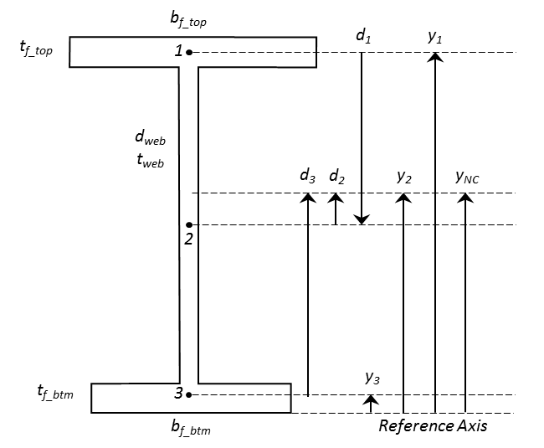

### Location of the Non-Composite Neutral Axis, yNC

The location of the neutral axis defines distance from the extreme fiber to the centroid of the cross-section. If the girder cross-section is symmetrical, the location of the neutral axis (also referred to as the location of the centroid) can be assumed as half of the depth of the girder. Otherwise, the equation for determining the location of the centroid (Equation X below) should be used.

|  |  |
| --- | --- |
| $$y_{NC}=\frac{\sum{A_{i}*y_{i}}}{\sum{A_{i}}}$$ | (2) |
| *Where, $A_{i}$*  *=* *Area of each component of the cross-section. $y_{i}$*  *= Distance to the centroid of each component from the reference axis* |  |

### Moment of Inertia, INC

The Moment of Inertia of the non-composite cross-section can be calculated using the Parallel Axis Theorem and the geometric properties of the girder. If the girder is a known rolled steel section, this value may be found in the AISC Steel Manual or another historical manual for rolled steel members. The equations below are used to determine the moment of inertia of the non-composite cross-section.

|  |  |
| --- | --- |
| $$I_{NC}= \sum{{\overline{I}}_{i}+A_{i}d_{i}^{2}}$$ | (3) |
| *Where, $${\overline{I}}_{i}= \frac{b_{i}h_{i}^{3}}{12}$$ $A_{i}$*  *= Area of each component of the cross-section. $d_{i}$*  *= Distance from the centroid of each component to the reference axis $b_{i}$*  *= width of component base $h_{i}$*  *= height of component base* |  |

### Section Modulus, SNC

The non-composite section modulus is used to convert the moment acting on the cross-section to the stress present in the extreme fiber due to that moment. The calculation for the section modulus is given by equation X below. Note: section modulus is defined for the top and bottom extreme fiber of the cross-section. For the non-composite section, the value for the top and bottom is the same.

|  |  |
| --- | --- |
| $$S_{NC}=\frac{I_{NC}}{y_{NC}}$$ | (4) |

## Composite Section Properties

Composite section properties include the stiffness contribution of the concrete deck. The equations used to calculate long term and short term composite section properties are defined in this section.

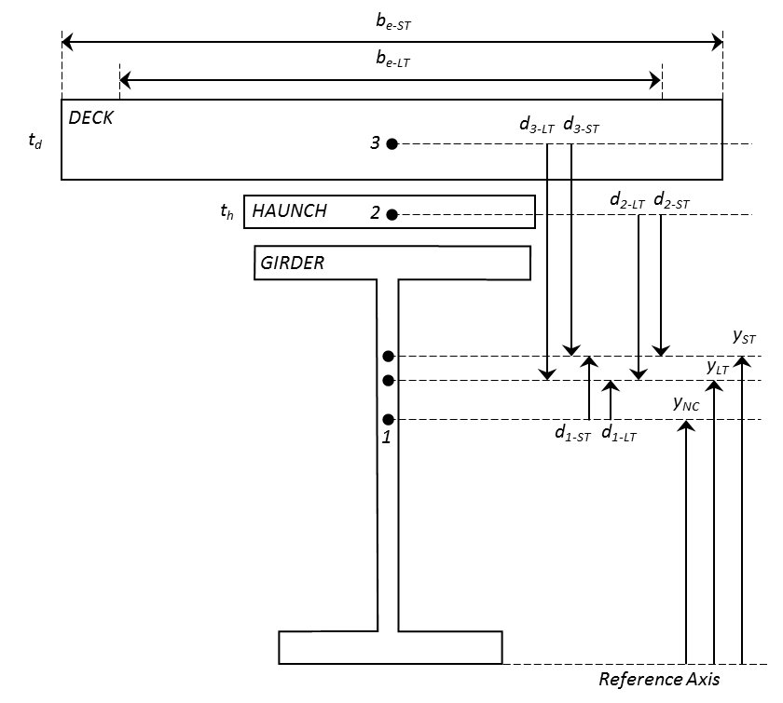

### Long Term vs. Short Term Composite

Long term composite section properties are used for permanent loads applied after the concrete slab has hardened (i.e. superimposed dead load). Short term composite section properties are used for transient loads applied after the deck has hardened (i.e. live load). Section properties are transformed into long term or short term by a factor of the modular ratio *n* as defined in Table X below.

|  |  |
| --- | --- |
| **Modular Ratio, *n*** | $$n= \frac{E_{s}}{E_{c}}$$ Where, $E_{s}$ = Modulus of Elasticity of Steel Girder $E_{c}$ = Modulus of Elasticity of Concrete Deck |
| **Long Term** | $$3n$$ |
| **Short Term** | $$n$$ |

### Effective Width & Area of Concrete Deck

The effective width (b*e*) of the concrete deck is defined as the tributary width of the deck between girders. For interior girders, the effective width is equal to half of the girder spacing. For exterior girders, the effective width is equal to half of the girder spacing plus the width of the overhang, if applicable. The effective width is transformed into long term (b*e-LT*) and short term (b*e-ST*) effective width by dividing by the respective long term (*3n*) and short term (*n*) modular ratio. The long term (A*LT*) and short term (A*ST*) effective area of the cross-section equals the thickness of the concrete slab multiplied by the respective effective widths. If a concrete haunch exists, the cross-sectional area of the haunch should be transformed in similar fashion. The long term and short term effective width and area are used in the calculation of other long term and short term composite section properties.

### Location of the Composite Neutral Axis, yLT & yST

The location of the neutral axis defines distance from the extreme fiber to the centroids of the long term and short term composite cross-sections. Equation X below is an extension of Equation 2, and can be used to determine the location of the long term and short term composite neutral axes.

|  |  |
| --- | --- |
| $$y_{LT,ST}=\frac{A_{NC}y_{NC}+\sum{A_{i-LT,ST}*y_{i-LT,ST}}}{A_{NC}+\sum{A_{i-LT,ST}}}$$ | (5) |
| *Where, $A_{NC}$*  *= Area of the non-composite cross-section. $A_{i-LT,ST}$*  *= Long term and short term area of each component of the cross-section. $y_{i-LT,ST}$*  *= Distance to the centroid of each component from the reference axis* |  |

### Composite Moment of Inertia, ILT & IST

Equation 6 below extends Equation 3 and is used to calculate the Moment of Inertia for the long term and short term composite section for sections that can be decomposed into rectangular components.

|  |  |
| --- | --- |
| $$I_{LT,ST}= I_{NC}+ A_{NC}{\left(y_{LT,ST}-y_{NC}\right)}^{2}+\sum{{\overline{I}}_{i-LT,ST}+A_{i-LT,ST}d_{i-LT,ST}^{2}}$$ | (6) |
| *Where, $${\overline{I}}_{i-LT,ST}= \frac{b_{i-LT,ST}h_{i}^{3}}{12}$$ $A_{i}$*  *= Area of each component of the cross-section. $d_{i}$*  *= Distance from the centroid of each component to the reference axis $b_{i}$*  *= width of component base (long term/short term effective width) $h_{i}$*  *= height of component base (i.e. thickness of deck or haunch)* |  |

### Composite Section Moduli, SLT & SST

In order to convert the moment acting on the composite cross-section to the stress present in the extreme fibers on the top and bottom of the section, the section modulus for the top and bottom of the long term and short term composite section must be calculated. To obtain these section moduli, the distances from the long term and short term composite neutral axes to the specified location of interest are needed. These can easily be calculated using the location of each of these axes and the geometric properties of the cross section. Figure X below depicts these values. Equations X through X are provided for the calculation of the composite section moduli.

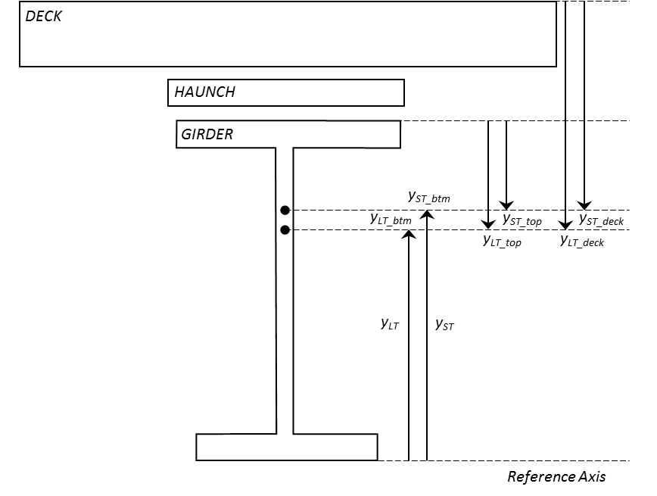

|  |  |
| --- | --- |
| $$S_{LT_deck}=\frac{I_{LT}}{y_{LT_deck}} , { S}_{ST_deck}=\frac{I_{ST}}{y_{ST_deck}}$$ | (7, 8) |
| $$S_{LT_top}=\frac{I_{LT}}{y_{LT_top}} , { S}_{ST_top}=\frac{I_{ST}}{y_{ST_top}}$$ | (9, 10) |
| $$S_{LT_btm}=\frac{I_{LT}}{y_{LT_btm}} , { S}_{ST_btm}=\frac{I_{ST}}{y_{ST_btm}}$$ | (11, 12) |

## Calculation of Capacity

Strength I, Service II, and Shear capacities are calculated per AASHTO LRFD and LFD specifications. For single span bridges, positive flexure resistance is evaluated at mid-span and shear resistance is evaluated over the supports. For multiple-span continuous bridges, positive and negative flexure resistance is evaluated at the location of maximum positive and negative flexure, and shear resistance is evaluated over the supports.

### LRFR

Positive flexure resistance of a composite section follows the specifications of AASHTO Article 6.10.7. Negative flexure resistance of composite and non-composite sections follow the specifications of AASHTO Article 6.10.8. Shear resistance follows the specifications of AASHTO Article 6.10.9.

#### Strength I Positive Flexure Resistance of Composite Section

The calculation of positive flexure resistance is dependent on if the section is compact (AASHTO Article 6.10.7.1) or non-compact (AASHTO Article 6.10.7.2). The following steps should be used to calculate the positive flexure capacity of a composite compact or non-compact section. The flowchart at the end of this section details these steps, adapted from the *Flowchart for LRFD Article 6.10.*7 found in Appendix C6 of the AASHTO Design Specifications.

##### Determine the plastic moment and plastic neutral axis of the composite section.

The plastic moment (*Mp*) of the composite section can be determined using the procedures outlined in AASHTO LRFD Appendix D6.

##### Determine if the section is compact or non-compact.

Composite sections in straight bridges that satisfy the requirements listed in Table X shall qualify as compact and should follow the specifications of AASHTO LRFD Article 6.10.7.1. Otherwise, the section is considered non-compact and should follow the specifications of AASHTO LRFD Article 6.10.7.2. If the section qualifies as compact, continue to step 3. Otherwise, move directly to step 5.

|  |  |
| --- | --- |
| **Requirements** | **AASHTO Article** |
| $$F_{y}≤70\frac{k}{{in}^{2}}$$ | 6.10.6.2.2 |
| $$\frac{D_{w}}{t_{w}} ≤150$$ $$D_{w}=Depth of Web$$ $$t_{w}=Thickness of Web$$ | 6.10.2.1.1, 6.10.6.2.2 |
| $$\frac{{2D}_{cp}}{t_{w}} ≤3.76\sqrt{\frac{E_{s}}{F_{yc}}}$$ $$D_{cp}=Depth of web in compression at plastic moment$$ $$t_{w}=Thickness of web$$ $$E_{s}=Steel modulus$$ $$F_{yc}=Yield strength of compression flange$$ | 6.10.6.2.2-1 |

##### Compute yield moment of composite section

The yield moment of the composite section can be determined using the provisions of AASHTO LRFD Appendix Article D6.2.2. The yield moment of a composite section in positive flexure shall be taken as the sum of the moments applied separately to the steel, short-term, and long-term composite sections to cause nominal first yielding in either steel flanges at the strength limit state, disregarding flange lateral bending (AASHTO LRFD). The yield moment is the sum of the total permanent loads plus the additional moment needed to cause nominal first yielding, and is taken as the lesser value calculated for the compression and tension flanges. The following equations can be used to determine the yield moment of the composite section in positive flexure.

|  |  |
| --- | --- |
| $$M_{add_{comp}}=\left[F_{y_{top}}-1.25\left(\frac{M_{DC1}}{S_{LT_{top}}}\right)-1.25\left( \frac{M_{DC2}}{S_{LT_{top}}}\right)- 1.50\left(\frac{M_{DW}}{S_{LT_{top}}}\right)\right]S_{ST_{top}}$$ | (13) |
| $$M_{add_{tens}}=\left[F_{y_{btm}}-1.25\left(\frac{M_{DC1}}{S_{LT_{btm}}}\right)-1.25\left( \frac{M_{DC2}}{S_{LT_{btm}}}\right)- 1.50\left(\frac{M_{DW}}{S_{LT_{btm}}}\right)\right]S_{ST_{btm}}$$ | (14) |
| $$M_{y_{comp}}=1.25\left(M_{DC1}+ M_{DC2}\right)+1.50 \left(M_{DW}\right)+ M_{add_{comp}}$$ | (15) |
| $$M_{y_{tens}}=1.25\left(M_{DC1}+ M_{DC2}\right)+1.50 \left(M_{DW}\right)+ M_{add_{tens}}$$ | (16) |
| $$M_{y}=min⁡(M_{y_{comp}}, M_{y_{tens}})$$ | (17) |
| *Where, $S_{LT_{top}}$*  *= Long-term composite section modulus of top flange $S_{LT_{btm}}$*  *= Long-term composite section modulus of bottom flange $S_{ST_{top}}$*  *= Short-term composite section modulus of top flange $S_{ST_{btm}}$*  *= Short-term composite section modulus of bottom flange $M_{DC1}$*  *= Maximum positive moment due to initial dead load $M_{DC2}$*  *= Maximum positive moment due to superimposed dead load $M_{DW}$*  *= Maximum positive moment due to wearing surface $M_{y}$*  *= Yield moment for positive flexure* |  |

##### Determine the nominal flexural resistance for the compact section.

The nominal flexural resistance for a compact composite cross-section in positive flexure is represented in the form of a moment (*Mn*) and is given by the provisions of AASHTO LRFD Article 6.10.7.1.2. Equations 18 and 19 are used to determine nominal moment resistance for simply supported bridges. Equations 20 and 21 are used to determine nominal moment resistance for multiple-span continuous.

|  |  |
| --- | --- |
| $M_{n}= M_{p} if D_{p} ≤0.1D$ | (18) |
| $M_{n}= M_{p} \left(1.07-0.7\frac{D_{p}}{D}\right) if D_{p} >0.1D$ | (19) |
| $$M_{n}= {min⁡(M}_{p} , 1.3R_{h}M_{y}) if D_{p} ≤0.1D$$ | (20) |
| $$M_{n}= {min⁡(M}_{p} \left(1.07-0.7\frac{D_{p}}{D}\right), 1.3R_{h}M_{y}) if D_{p} >0.1D$$ | (21) |
| *Where, $D_{p}$*  *= Distance from the top of the concrete deck to the neutral axis of the composite section at the plastic moment (in.) $D$*  *= Total depth of the composite section $R_{h}$*  = *Hybrid factor as specified in AASHTO Article 6.10.1.10.1 (for sections with differing yield strength)* |  |

##### Determine the nominal flexural resistance (for non-compact section).

The nominal flexural resistance for a non-compact composite cross-section in positive flexure is represented in the form of a stress (*Fn*) and is given by the provisions of AASHTO LRFD Article 6.10.7.2.2. Equations 22 through 24 are used to determine nominal flexural stress resistance of a composite cross-section in positive flexure.

|  |  |
| --- | --- |
| $F_{n_{comp}}= R_{b}R_{h}F_{yc}$ | (22) |
| $F_{n_{tens}}= R_{h}F_{yt}$ | (23) |
| $$F_{n}= min⁡(F_{n_{comp}} , F_{n_{tens}})$$ | (24) |
| *Where, $F_{yc}$*  *= Yield strength of tension flange. $R_{h}$*  *= Hybrid factor as specified in AASHTO Article 6.10.1.10.1 (for sections with differing yield strength) $R_{b}$*  = *Web load-shedding factor determined as specified in AASHTO LRFD Article 6.10.1.10.2* |  |

#### Strength I Negative Flexure Resistance of Composite & Non-Composite Section

The nominal flexure resistance of a cross-section in negative flexure is taken as the lesser value calculated for the continuous or discretely braced flanges in tension or compression. A flange in tension or compression is considered continuously braced if connected to a continuous structural component such as a continuous concrete deck. Otherwise, the flange is considered discretely braced. The resistance to tension or compression of the continuous or discretely braced top flange is specified by AASHTO Article 6.10.8.3 and is given by Equation 25 below.

|  |  |
| --- | --- |
| $F_{n_{top}}=R_{h}F_{y_{top}}$ | (25) |
| *Where, $R_{h}$*  *= Hybrid factor as specified in AASHTO Article 6.10.1.10.1 (for sections with differing yield strength)* |  |

The nominal resistance of a discretely braced flange in compression is taken as the lesser of the flange local buckling resistance (FLB) and the lateral torsional buckling resistance (LTB). FLB and LTB resistances are specified in AASHTO Articles 6.10.8.2.2 and 6.10.8.2.3, respectively. The following steps should be used to calculate the FLB, LTB, and overall nominal flexural resistance for a discretely braced compression flange in negative flexure.

##### Determine the compression flange local buckling resistance (FLB) per AASHTO 6.10.8.2.2.

The calculation for the FLB resistance differs depending on whether the compression flange is compact or non-compact as defined by the slenderness ratio for the compression flange (λf) and the limiting slenderness ratios for a compact (λpf) and non-compact (λrf) flange. The slenderness ratio for the compression flange and the limiting slenderness ratios for compact and non-compact are listed in Table X.

|  |
| --- |
| **Slenderness Ratio(s)** |
| $$λ_{f}=\frac{b_{fc}}{{2t}_{fc}}$$ $$λ_{f}=Slenderness ratio of compression flange$$ $$b_{fc}=Width of compression flange$$ $$t_{fc}=Thickness of compression flange$$ |
| $$λ_{pf}= 0.38\sqrt{\frac{E_{s}}{F_{yc}}}$$ $$λ_{pf}=Limiting slenderness ratio of compact flange$$ $$E_{s}=Modulus of steel$$ $$F_{yc}=Yield strength of compression flange$$ |
| $$λ_{pf}= 0.56\sqrt{\frac{E_{s}}{F_{yr}}}$$ $$E_{s}=Modulus of steel$$ $$F_{yr}=Compression flange stress nominal yielding= \min\left(0.7F_{yc} , F_{yw}\right)>0.5F_{yc}$$ $$F_{yw}=Yield strength of web$$ |

The FLB resistance for a compact and non-compact compression flange is given by Equations 26 and 27, respectively.

|  |  |
| --- | --- |
| $F_{LB}= R_{b}R_{h}F_{yc} if λ_{f} ≤ λ_{pf} (Compact)$ | (26) |
| $F_{LB}= {\left[1-\left(1-\frac{F_{yr}}{R_{h}F_{yc}}\right)\left(\frac{λ_{f} - λ_{pf}}{λ_{rf} -{ λ}_{pf}}\right)\right]R}_{b}R_{h}F_{yc} if λ_{f} > λ_{pf} (Non-Compact)$ | (27) |

##### Determine the lateral torsional buckling resistance of the compression flange (FLT) per AASHTO 6.10.8.2.3.

The calculation of the LTB resistance of the compression flange differs depending on whether the unbraced length of the compression flange is compact, non-compact or slender. The limits for compact unbraced length (Lp) and non-compact unbraced length (Lr) are given in Table X.

|  |
| --- |
| **Limits for Compact and Non-Compact Unbraced Length** |
| $$L_{p}= 1.0{ r}_{t}\sqrt{\frac{E_{s}}{F_{yc}}}$$ $$L_{p}=Limit for compact unbraced length$$ $$r_{t}=effective radius of gyration for lateral torsional buckling$$ $$r_{t}= \frac{{}_{}}{\sqrt{12\left(1+\frac{1}{3}\frac{{}_{}{}_{}}{{}_{}{}_{}}\right)}}$$ |
| $$L_{p}= π r_{t}\sqrt{\frac{E_{s}}{F_{yc}}}$$ $$L_{p}=Limit for non-compact unbraced length$$ |

#### Service II

Flexural resistance for the Service II limit state is determined per the provisions of AASHTO LRFD Article 6.10.4. Equations X and X are used to determine the flexural resistance for the Service II limit state.

|  |  |
| --- | --- |
| $$F_{n}= 0.95R_{h}F_{y} (for top and bottom steel flange of composite sections)$$ | (X) |
| $$F_{n}= 0.80R_{h}F_{y} (for both steel flange of non-composite sections)$$ | (X) |
| *Where, $R_{h}$*  *= Hybrid factor as specified in AASHTO Article 6.10.1.10.1 (for sections with differing yield strength)* |  |

#### Shear

### LFR

#### Strength I - Positive Flexure of Composite Section

#### Strength I - Negative Flexure of Composite & Non-Composite section

#### Service II

#### Shear

# Load Rating

## Capacity Used in Load Rating

## Responses Used in Load Rating

## Load Rating Factors

|  |  |  |  |  |
| --- | --- | --- | --- | --- |
| **FACTORS** | LRFR | | LFR | |
| Strength I | Service II | Strength I | Service II |
| Capacity (+) | 1.00 | 1.00 | 1.00 | 1.00 |
| Capacity (-) | 1.00 | 1.00 | 1.00 | 1.00 |
| Dead Load (DC) | 1.25 | 1.00 | 1.30 | 1.30 |
| Wearing Surface (DW) | 1.50 | 1.00 | 1.30 | 1.30 |
| LL: HL-93 Inventory | 1.75 | 1.30 | - | - |
| LL: HL-93 Operating | 1.35 | 1.00 | - | - |
| LL: HS-20 Inventory | - | - | 2.17 | 1.67 |
| LL: HS-20 Operating | - | - | 1.30 | 1.00 |
| Legal Loads: Inv. | 1.45 | 1.30 | 2.17 | 1.67 |
| Legal Loads: Op. | 1.45 | 1.00 | 1.30 | 1.00 |

## Load Rating Equation

## Reporting of Controlling Load Rating

## Error Screening

## Error Screening

The error screening process is a checkup done by other members of the team where point of interest are revised to confirm that results extraction, capacity and rating values are accurate.